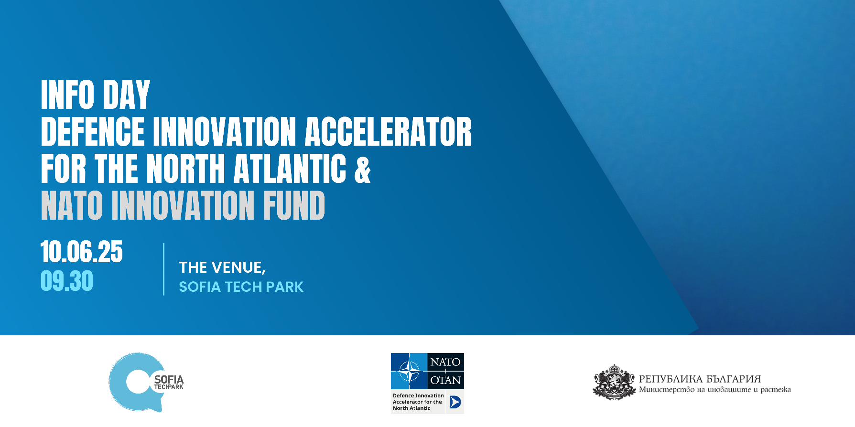

DEFENSE INNOVATION ACCELERATOR FOR THE NORTH ATLANTIC (DIANA) THE NEW CHALLENGES AND THE APPLICATION PROCESS
Keynote speaker: Emma Ryan, Challenge Manager at DIANA

PROGRAMME
9:30 – 10:00 Registration
10:00 – 10:15 Official opening
10:15 - 11:45 First session: What is DIANA and how to apply?
- What is DIANA?
  - Description of challenge formation, application, evaluation, Phase 1, Phase 2, test centers, rapid adoption and alumni network.
  - Explaining the different accelerator sites and test center network
  - Overview of previous cohorts, their progress in DIANA and their successes / impact / achievements
- How to apply to DIANA?
  - The new challenges for 2025 cohorts
  - Description of application process
  - Present on the proposal templates and how to fill them out
  - Describe what makes a good / bad proposal
- Q&A

11:45 – 12:00 Coffee break
12:00 –13.30 Third session: Application workshop
Facilitate a workshop for start-ups and others in the audience to complete a quad chart and then evaluate together.
- Share fictitious challenge statement / topic
- Complete quad chart
- Evaluate 2 selected quad charts
- Share evaluations with the whole audience
- Q&A
13:30 14:30 Lunch break
14:30 – 16:30 Third session: Acceleration sites, Test centers & Companies
- Ben Balmforth – NATO Innovation Fund
- Kaari Kink– DIANA Estonia
- Yanislav Trendafilov - Neuromorphica – the first Bulgarian company in DIANA
- Borislav Bankov – GATE Institute, test center
- Col. Borislav Genov – Bulgarian Defense Institute, test center
- Mihail Iliev – R&D&I Consortium (at Sofia Tech Park) – test center
- Q&A

