Technical Instructions
on
how to complete the online application form
in the
National Investments Management System

- Introduction
The project proposals are submitted through the National Investments and Management System (NIMS) at https://enims.egov.bg/ with a qualified electronic signature. You can use any electronic signature that allows you to sign a document with a detached signature.

- Navigating the system
The project proposals are submitted through section “E-APPLICATION” in NIMS, for which you will need to register in the system.

- How to register
You can start your registration process by clicking on section “E-APPLICATION” from the home page:

After that you click on “LOG IN SYSTEM”:
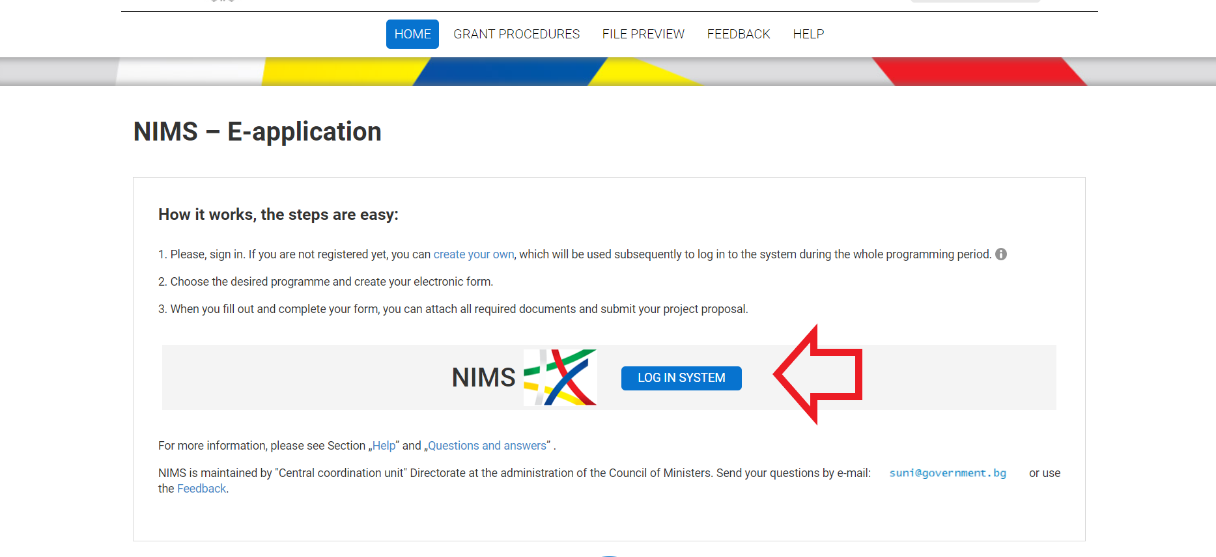
and “NEW USER”:
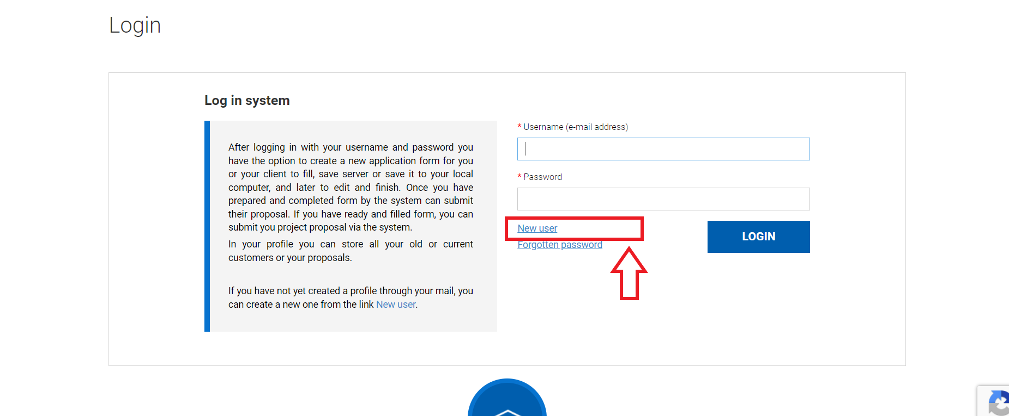
The system will generate a registration form. After you fill in the information and make sure that it is correct, you can click on “CONTINUE”. The system will send you an email to the email address that you have provided, with a link for confirmation of the registration:
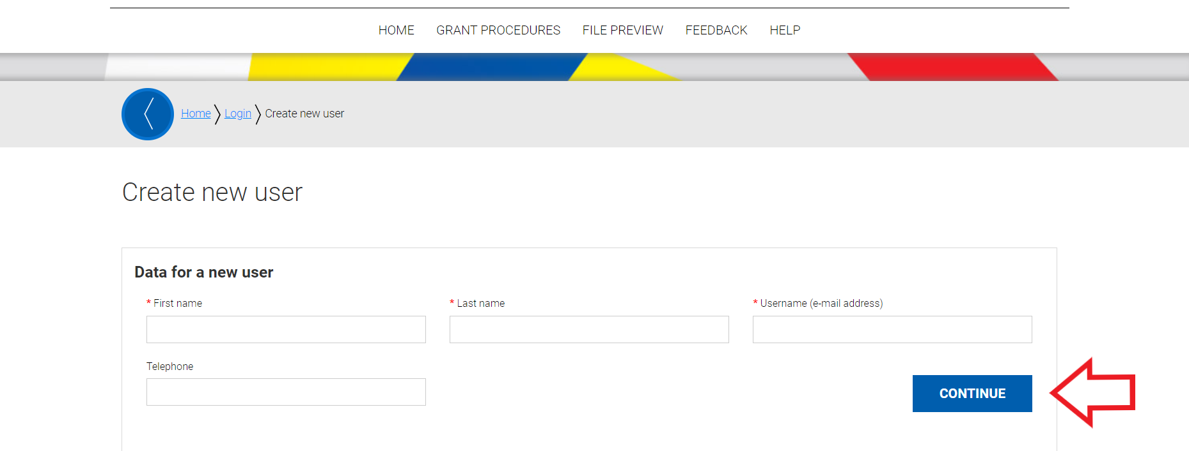
After you click on the link that has been sent to your email, you will be directed to the following page:
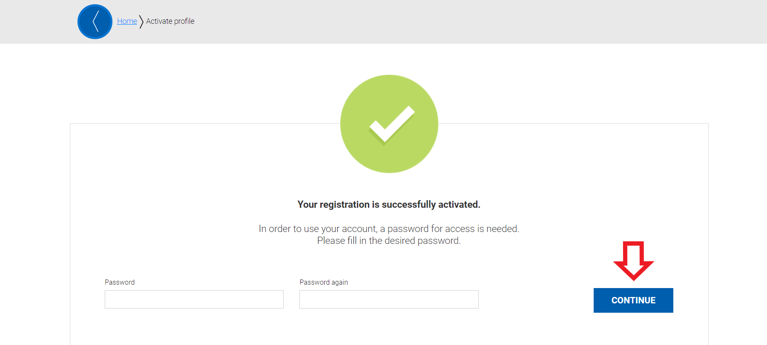
Upon the creation of your password and clicking the button “CONTINUE” you will be directed to the “GRANT PROCEDURES” tab in the system.
- Creating the online form
From the home page you can click on “NEW PROPOSAL” for the start of the application process:
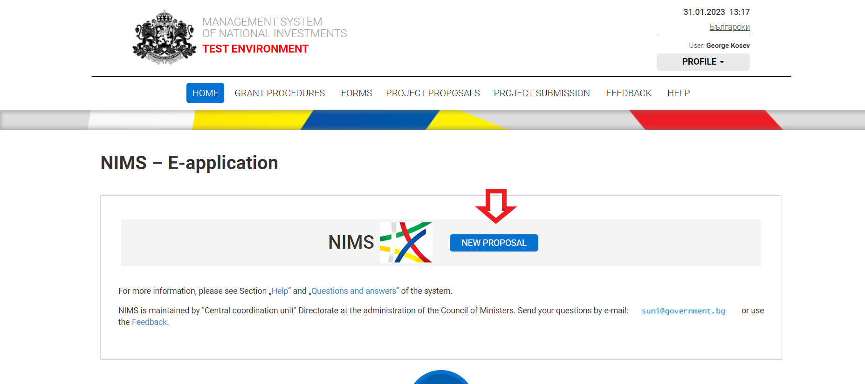
Additionally, a new proposal could be started by clicking on the “GRANT PROCEDURES” tab from the home page, then finding the “Ministry of Innovation and Growth” and clicking on the procedure “BG-177549112-2023-01”:
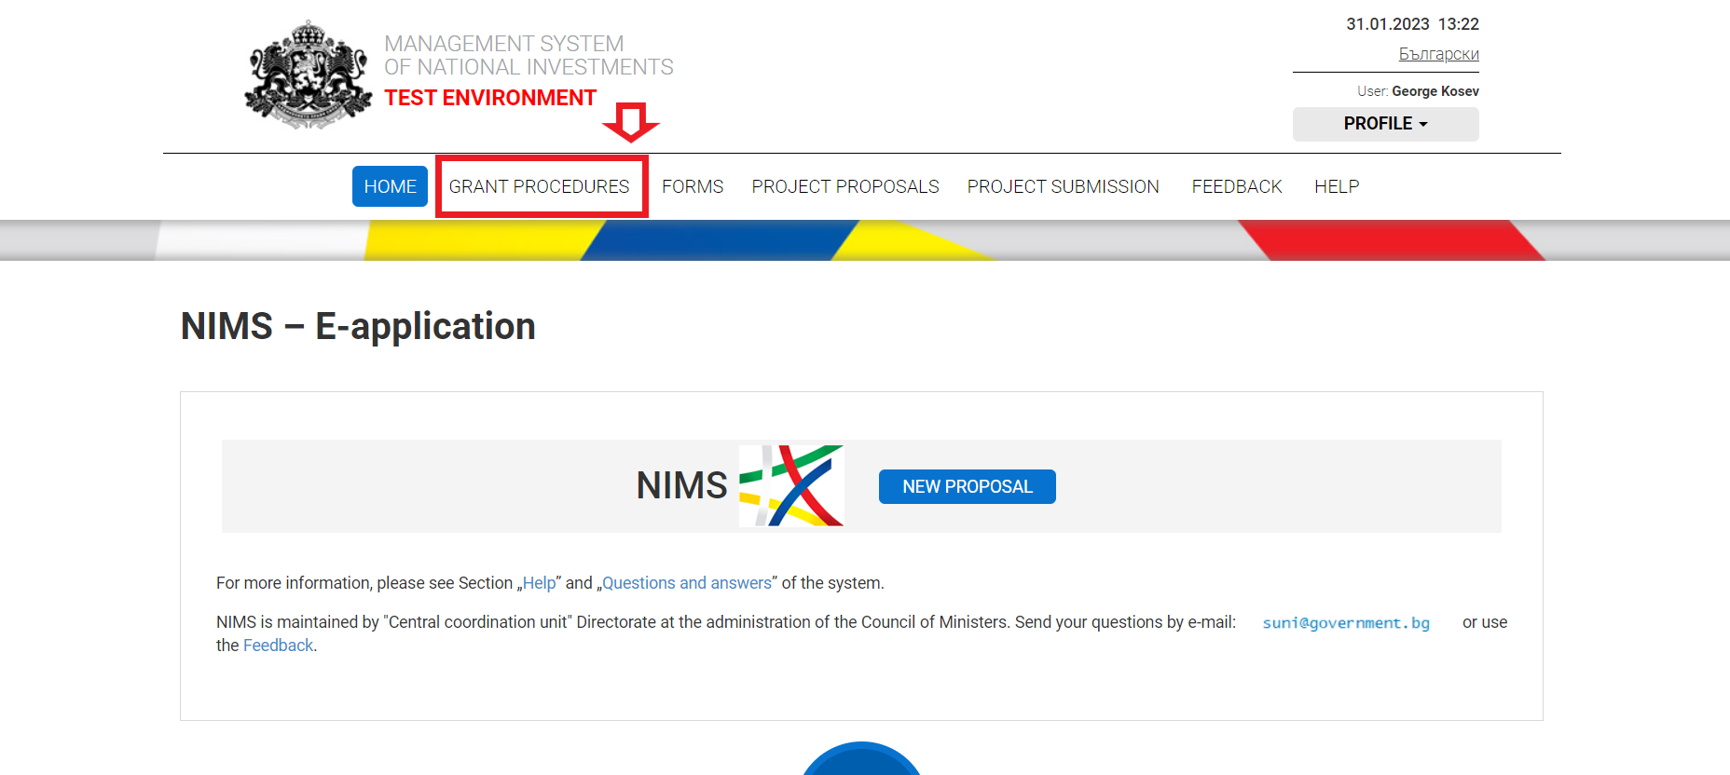
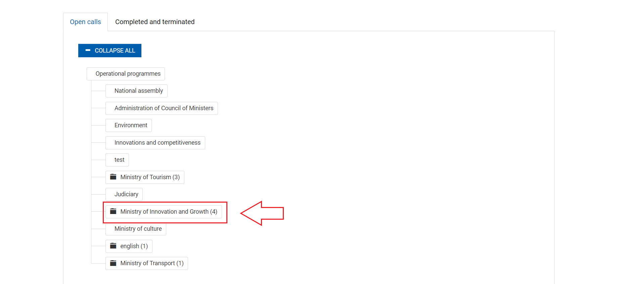
Once you click on the procedure “BG-177549112-2023-01”, you will be taken to a page with a little more information on the procedure and the current file for Technical Instructions on how to complete the online application form in the National Investments Management System. Here you need to click on the “NEW PROPOSAL” button:
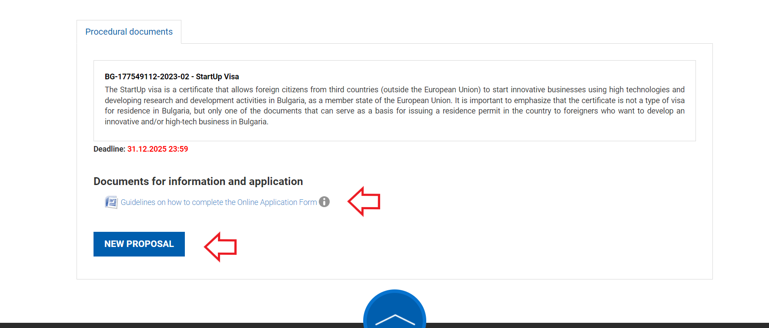

You will be guided to the following page:
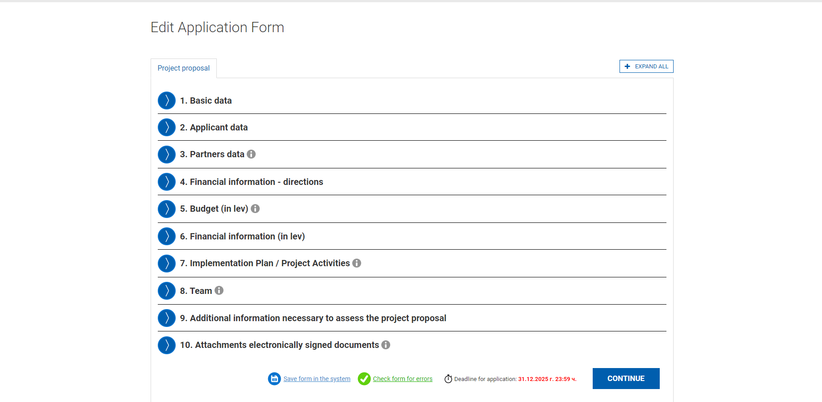
- Basic data
Here you must enter the name of the project proposal in both sections “Name of the project proposal”, “Name of project proposal in English”:
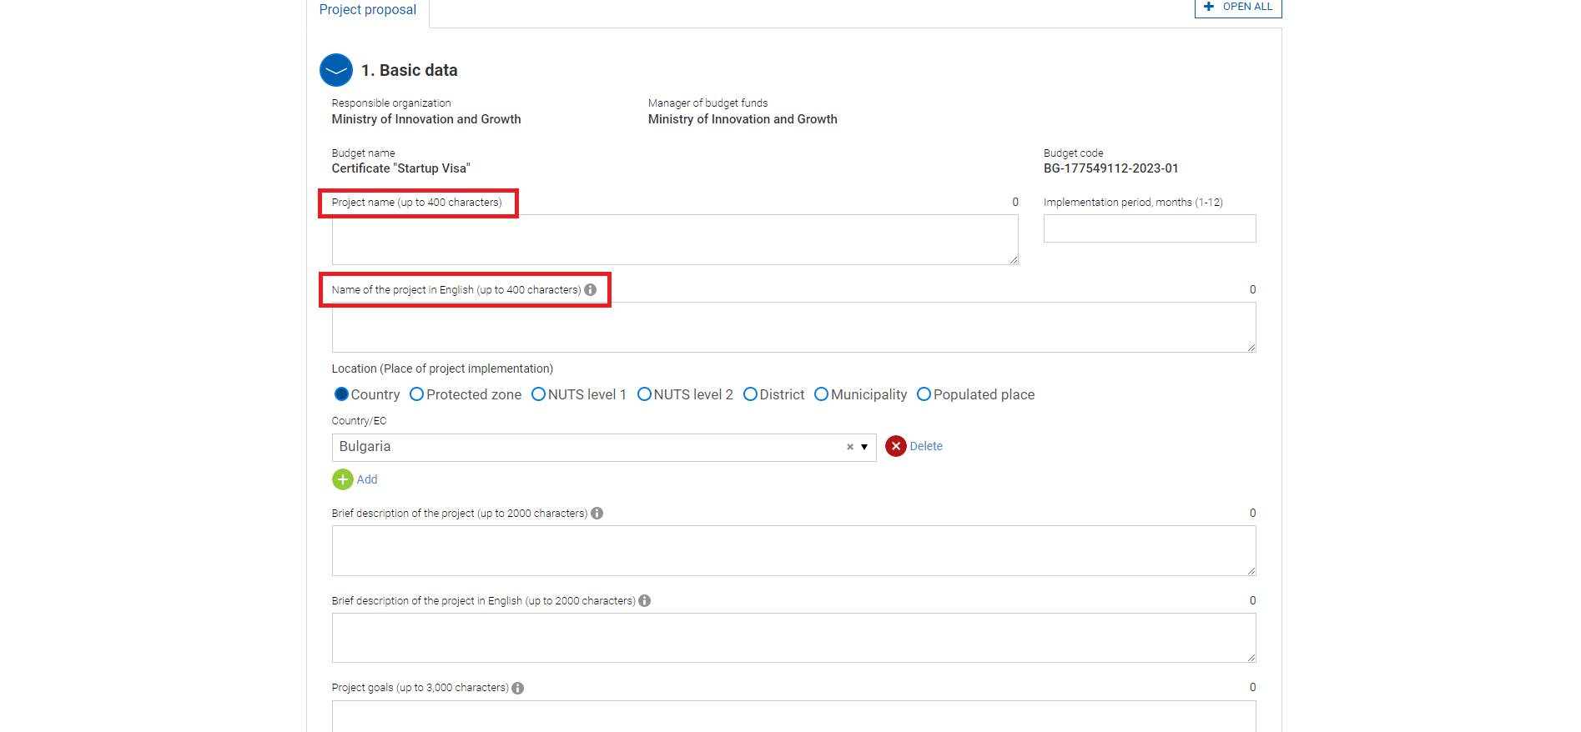
In “Location” you must select “Country” and select “Bulgaria” from the drop-down menu: 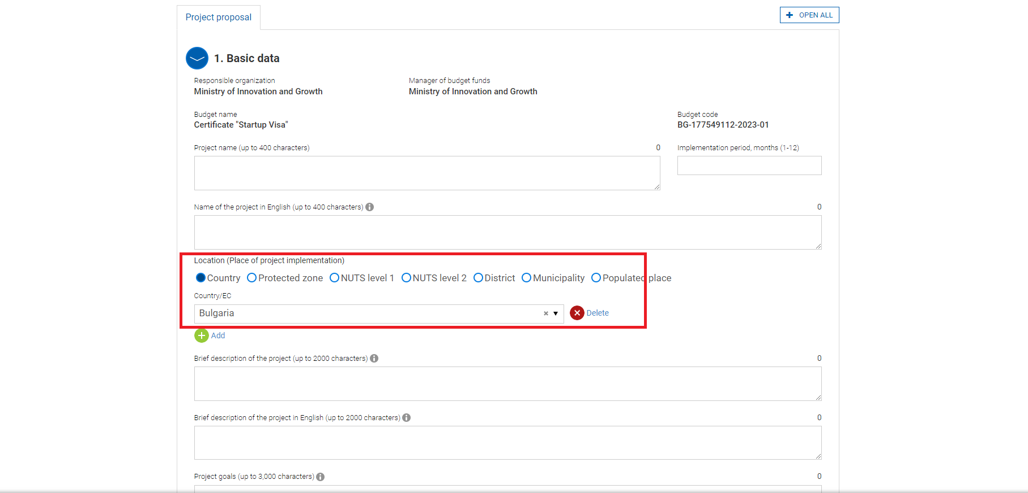
In “Execution period, months” you must put 12, as the StartUp Visa certificate is valid for 1 year.
The bottom three fields “Brief description of the project proposal”, “Brief description of the project proposal in English” and “Objective/s of the project proposal” you must place the respective information. (The field “Brief description of the project proposal in English” must be completed or it will show an error.):
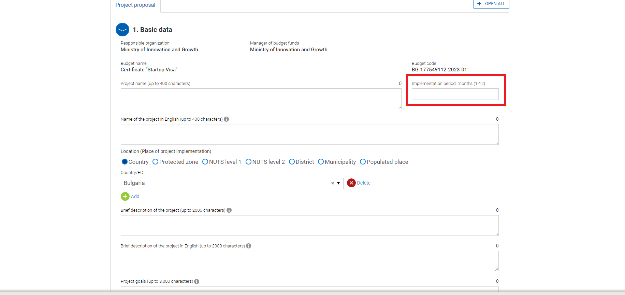

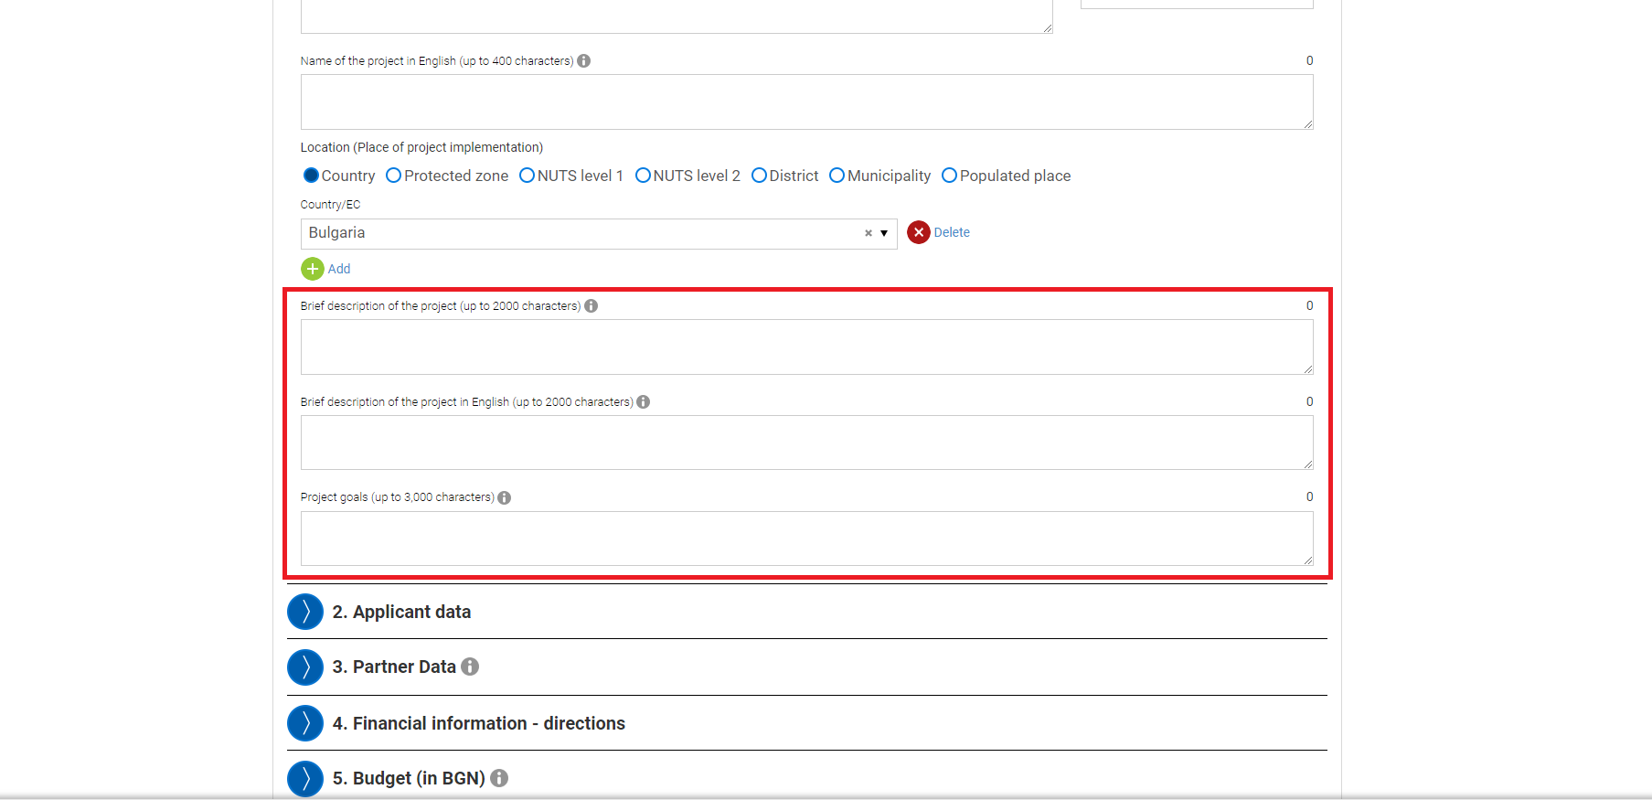

- Applicant data
Here you must input your personal information: UIC or BULSTAT, Full Name, Type of Organization, Organization kind, Settlement, Management address, Correspondence address; in the following fields:

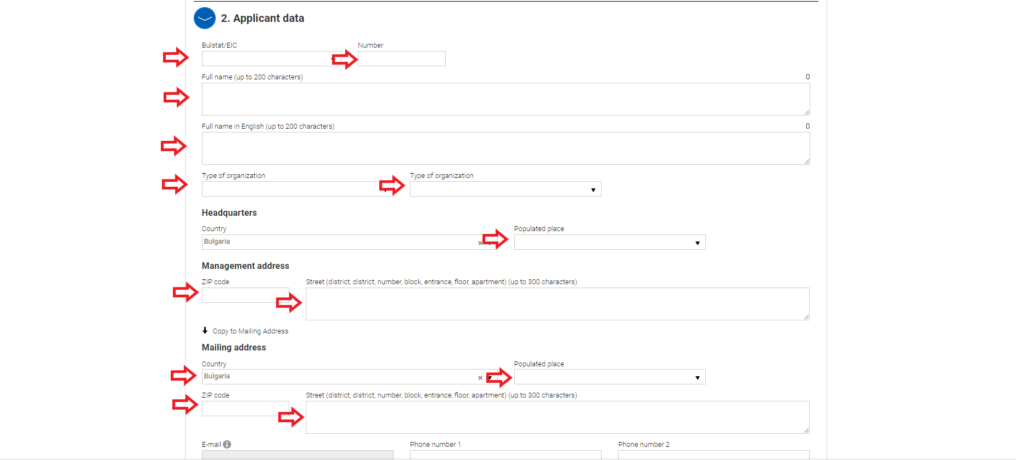
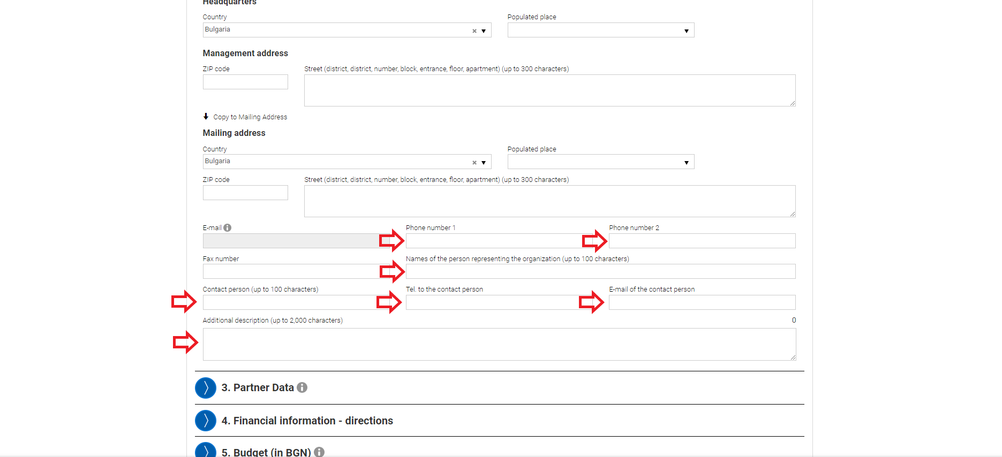

- Partners data
Here you must input the partners’ information that you have currently, for the purposes of the project you are applying with (in case you have one) in the same way as you have input the information in Applicant’s data.
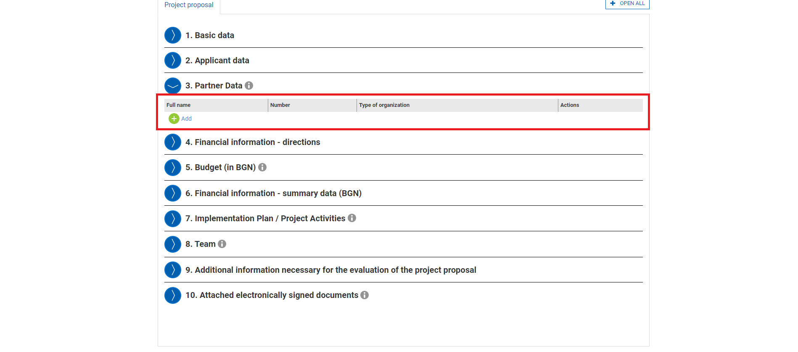

- Financial information – directions
Here you must enter the business field of your organizations from the ones pre-selected in the drop-down menu:
First you have to click on “Add”:
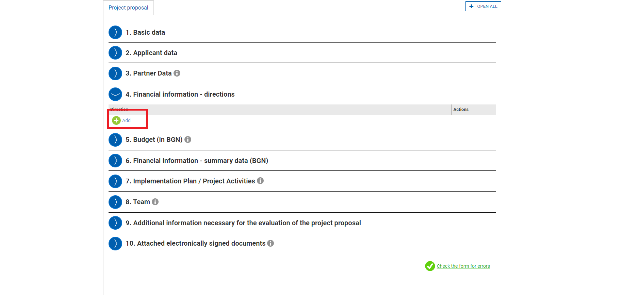
Than you have to select your field (directions) of business from the both drop down menus:
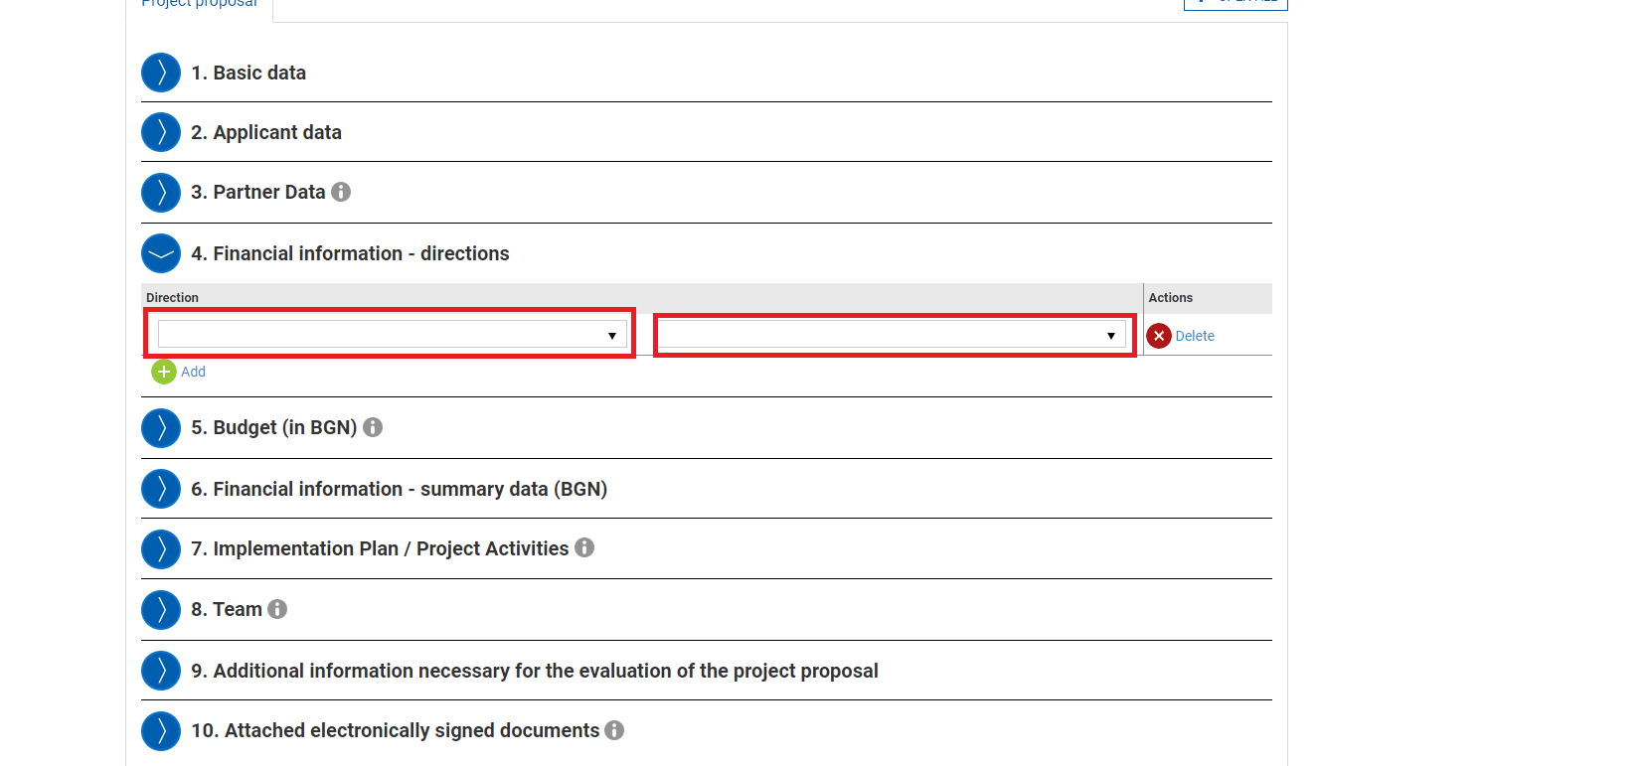

- Budget (in lev)
The procedure for issuing the certificate “StartUp Visa” is free of charge and requires no budget. In this filed you must write “Not Applicable” and select the direction (field of business) that you have put in in Financial information – directions in the second drop-down field.
The amount at the end must be exactly 0.00.
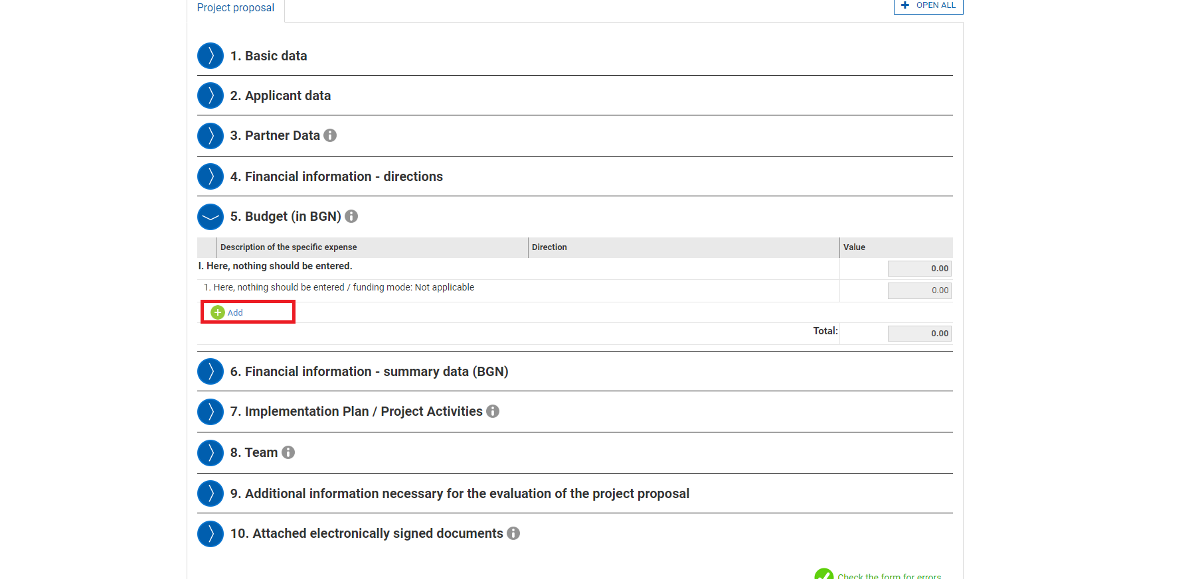

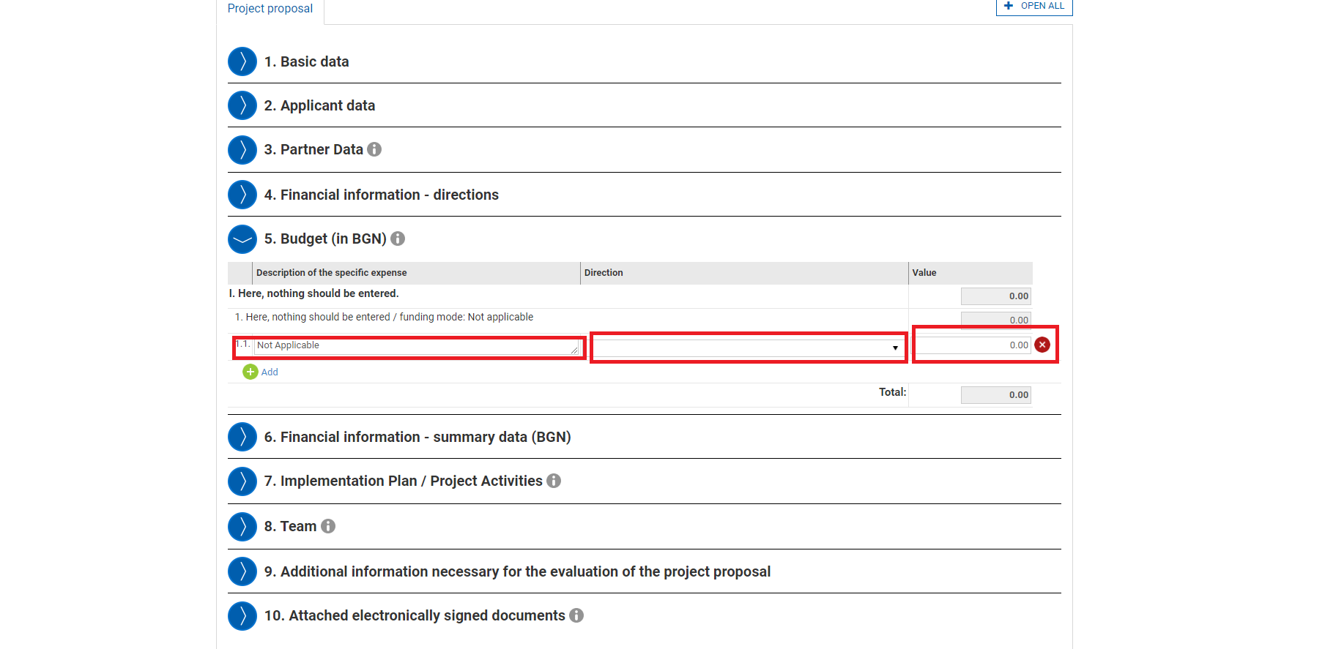

- Financial information (in lev)
Here the system will automatically select the amount that you have selected in the previous field.

- Implementation Plan / Project Activities
In this section you must add the activities that the company will be implementing with the corresponding details in the boxes. If there are any boxes that are required and not completed, the system will show them as an error, in red.

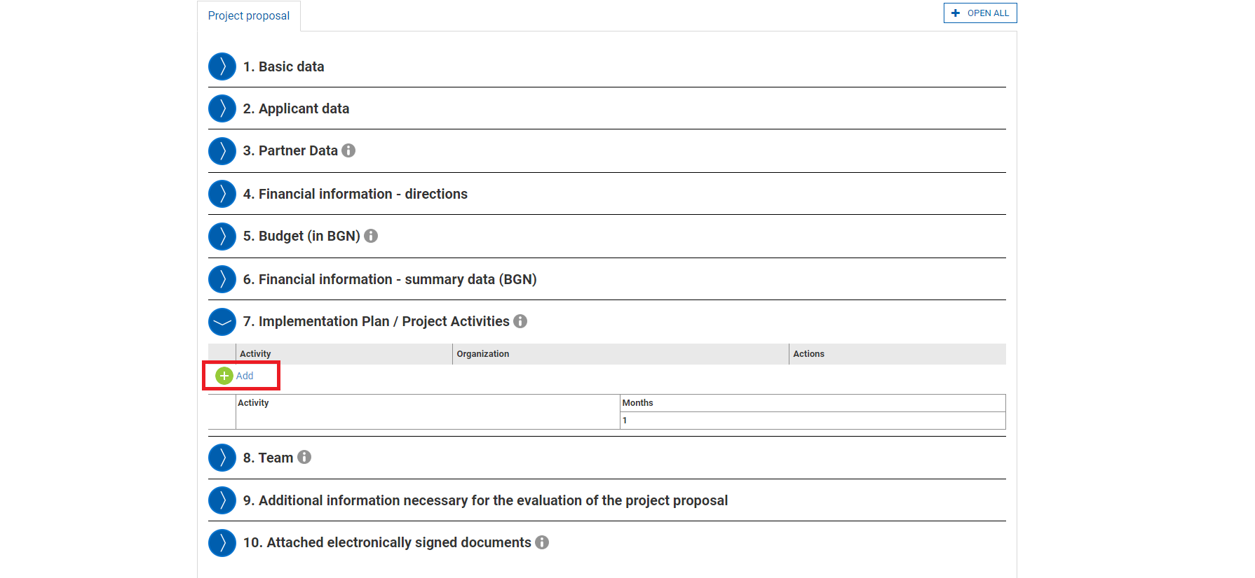
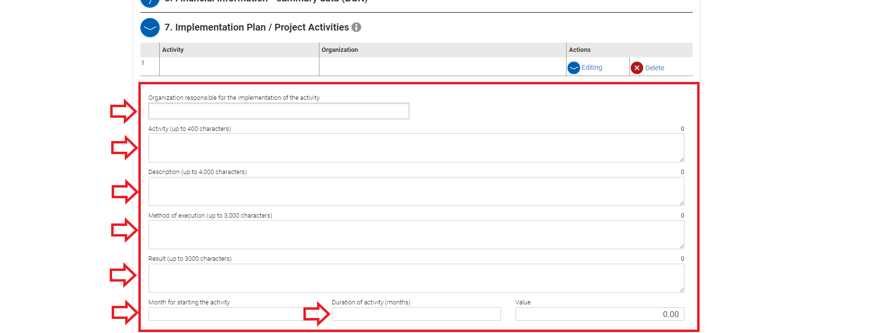
*In “Activity duration” the number of months has to correspond to the duration of the certificate – 12 months. This must be the input in the field. If there are any activities that will take longer than 12 months in section 9 – “Additional information necessary to assess the project proposal” you can describe them in further detail.
- Team
Here you must enter the number of team members. If you will be the only team member, you have to input only your information. Otherwise the system will not allow you to continue, as at least one member is required.
The information that is required for the team members is Name, Position, Qualification and Responsibilities, Phone number and Email.

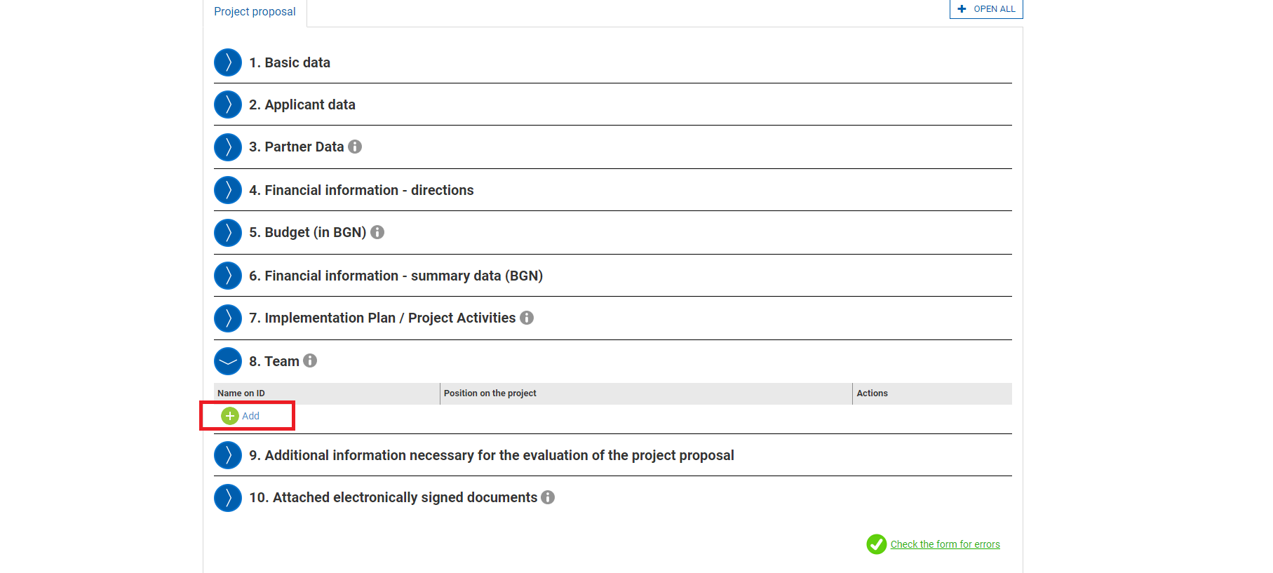
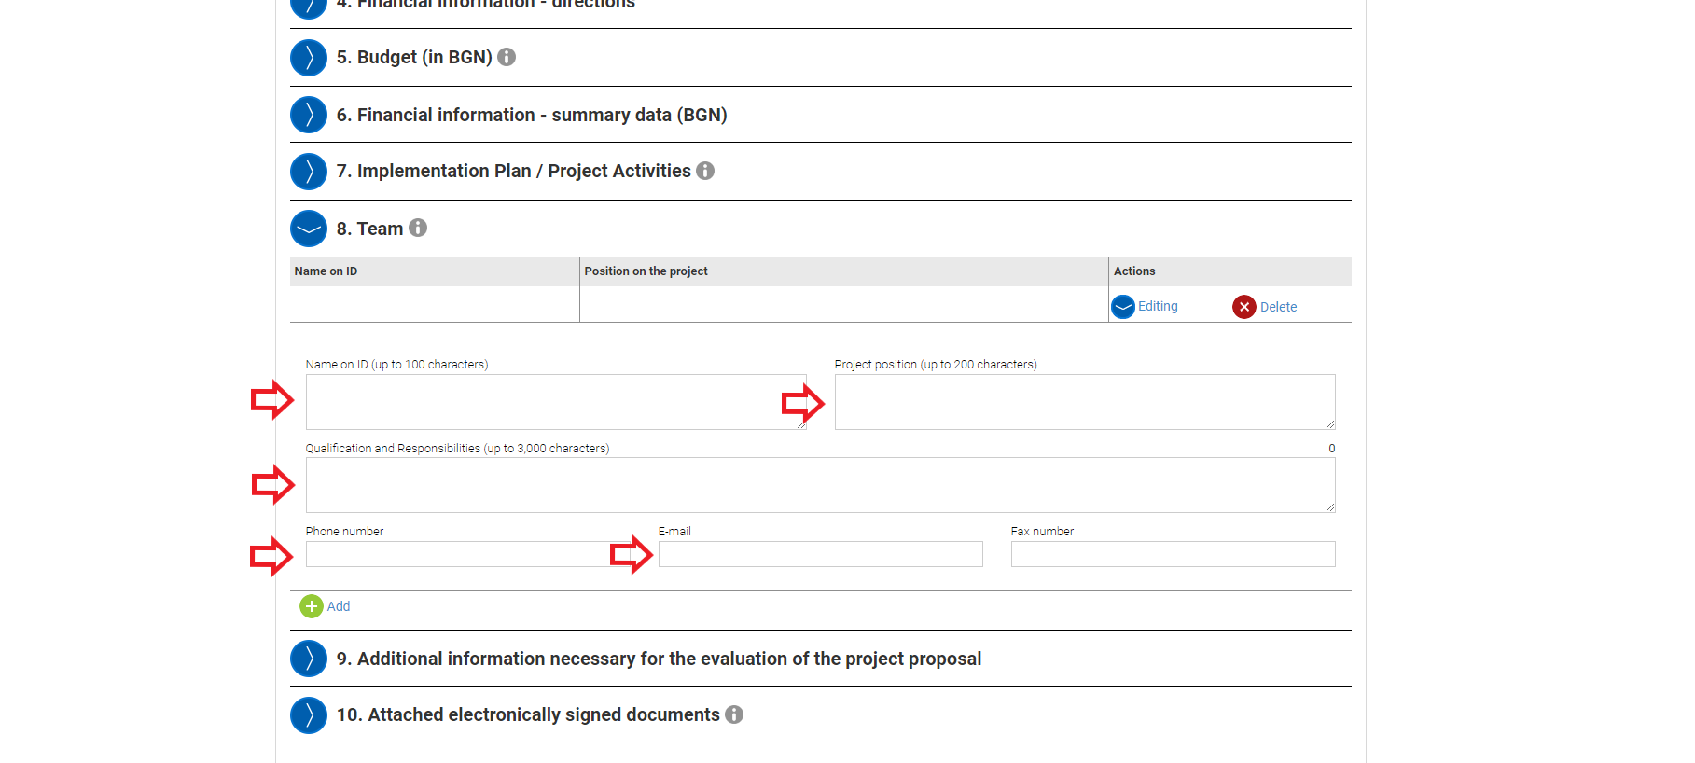
- Additional information necessary to assess the project proposal
Here you can add any additional information that you think will be valuable in evaluating the project proposal.
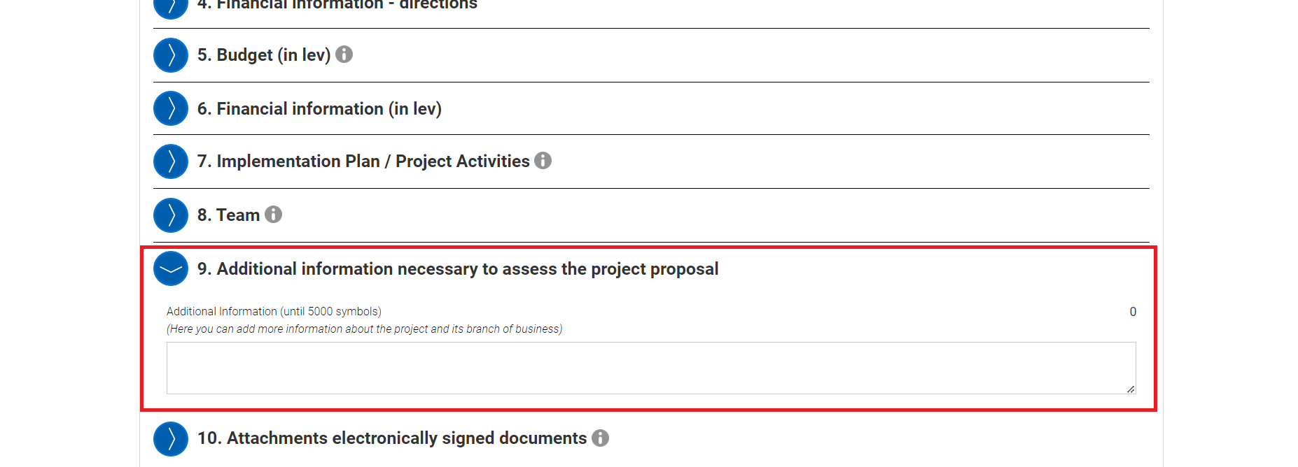

- Attachments:
Here you must upload the required documents for the evaluation of the project proposal.
There are 13 documents in total, from which 3 are mandatory:
- Appendix 1 - Identity document
- Appendix 2 - Business plan and project presentation
- Appendix 10 - Bank or equivalent document certifying the availability of personal funds of the applicant for at least 30 consecutive days before the date of the application, covering the amount of at least three minimum wages in the Republic of Bulgaria
and the rest are optional:
- Appendix 3 - Document for a valid invention patent or a valid utility model registration certificate
- Appendix 4 - Investment contract with a specialized international equity and risk investment fund
- Appendix 4.1 - A recommendation issued by the relevant fund for the applicant's contribution to the project
- Appendix 5 - Contract or letter of intent for investment from a fund for equity and risk investing in the Republic of Bulgaria
- Appendix 6 - Quality project certificate (Seal of Excellence) under the programs "Horizon 2020" or "Horizon Europe"
- Appendix 7 - Proof that the project has been awarded in a specialized competition in the field of innovation and entrepreneurship organized by the European Commission or the European Space Agency
- Appendix 8 - Evidence of publication of at least two scientific articles in the upper quartiles Q1 or Q2 in the international databases Scopus or Web of Science
- Appendix 9 - Document for completed education degree
- Appendix 11 - Information on realized sales related to the activity, product or service, proven by contracts, expense justification documents and bank statements for a minimum of BGN 100,000 for the last two years
- Appendix 12 - Letters of intent or partnership agreements with Bulgarian partners
You have to click on “Add”:
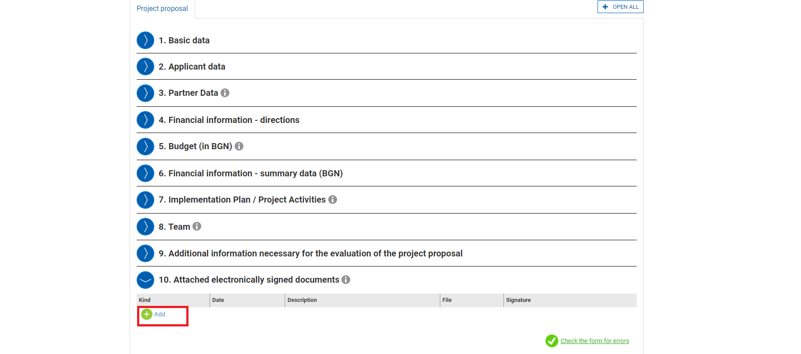
Than you must select the document from the drop-down menu:
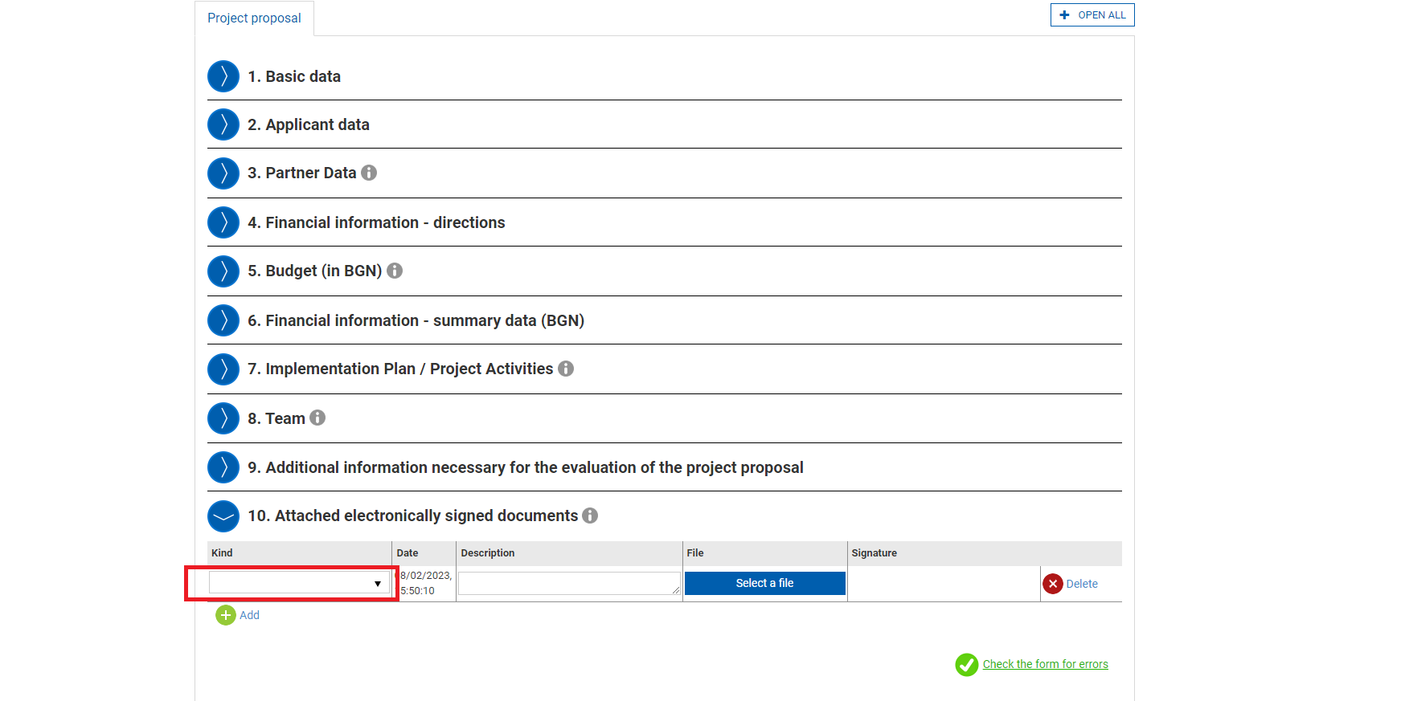
Write the description of the project and upload the file in the allowed extension:
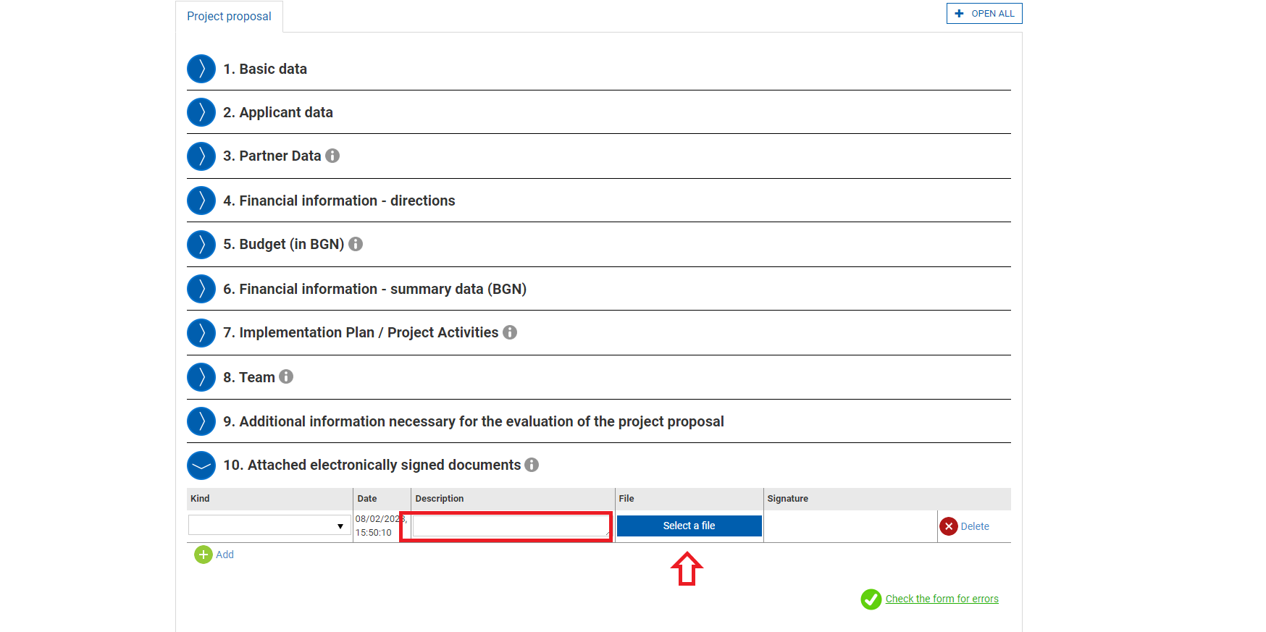

*These documents are not required to be electronically signed as you will be required to sign the whole application form with a qualified electronic signature.
Once you have completed the form you can than press “CONTINUE” to proceed:
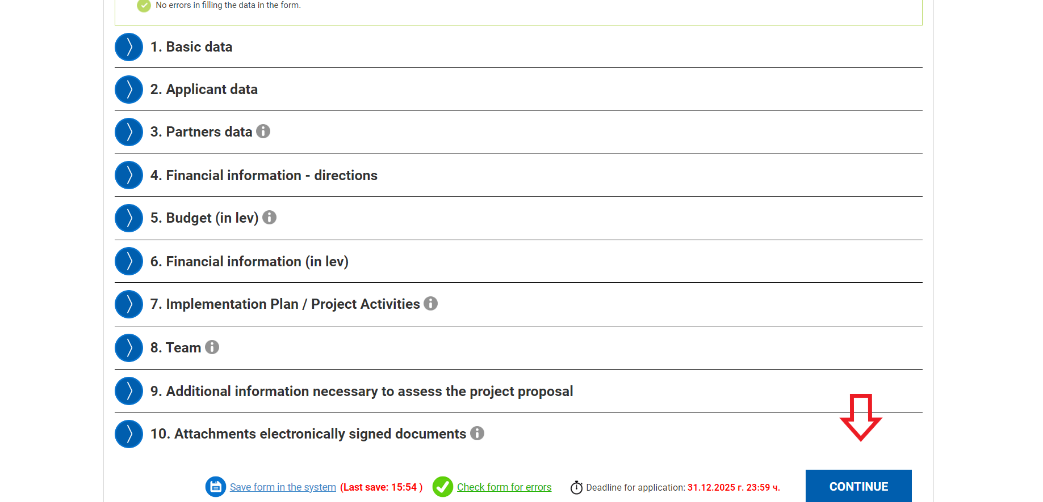

After that you press on complete:
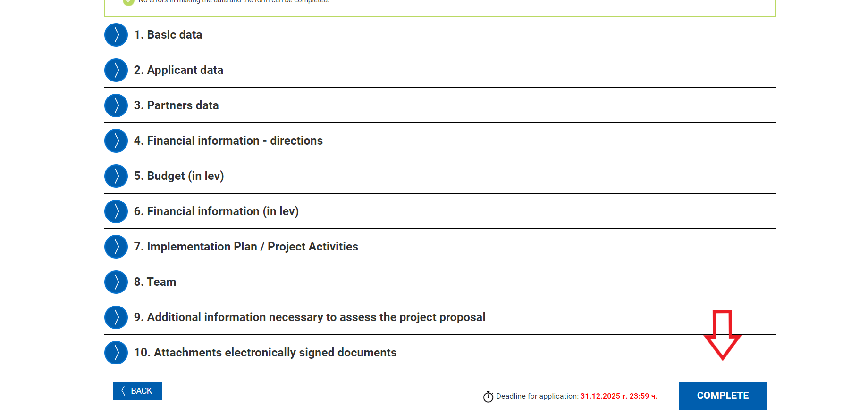

Once you have pressed on “COMPLETE” you will be shown the following message:
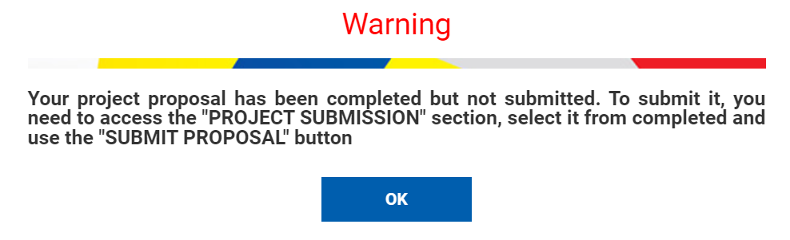

Now you are ready to move to submitting the project proposal:
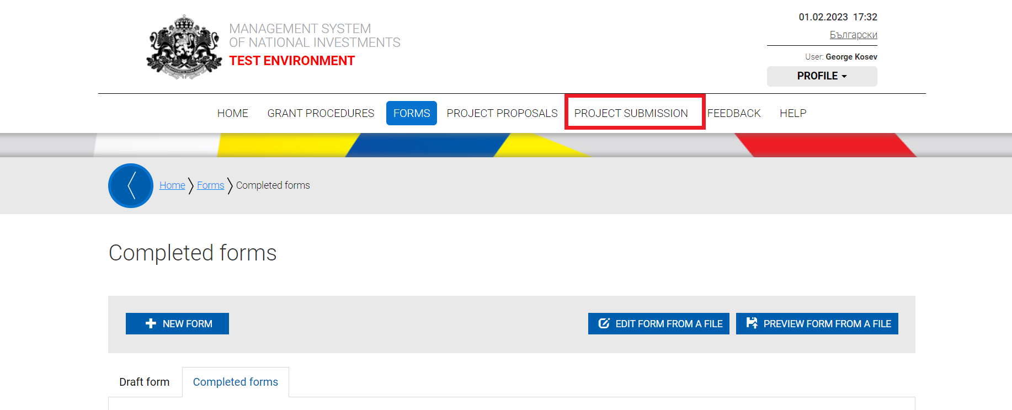

After clicking on “PROJECT SUBMISSION” you will be taken to the following screen, from which you need to agree that during the "Project Proposal Assessment" stage the communication and editing of inaccuracies noted to be done electronically via this account associated with your email address and press on “CONTINUE”:
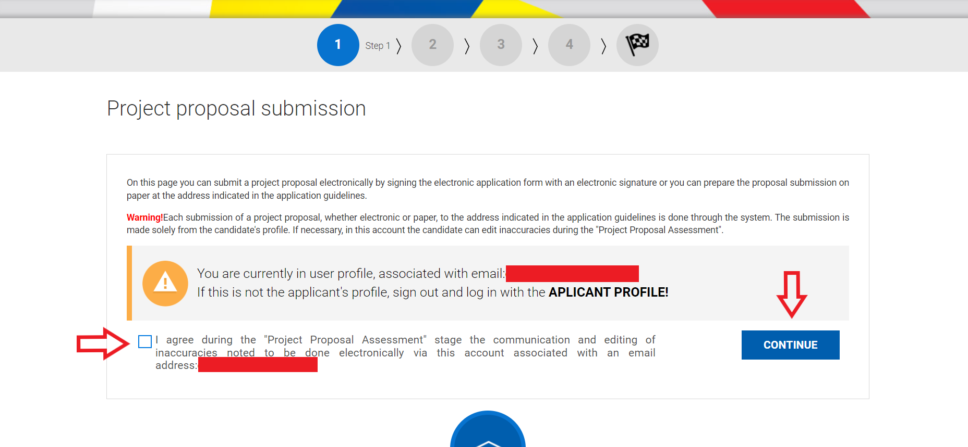

Once you click on continue you will be shown the following screen, from which you must select “SELECT FROM COMPLETED FORMS”:
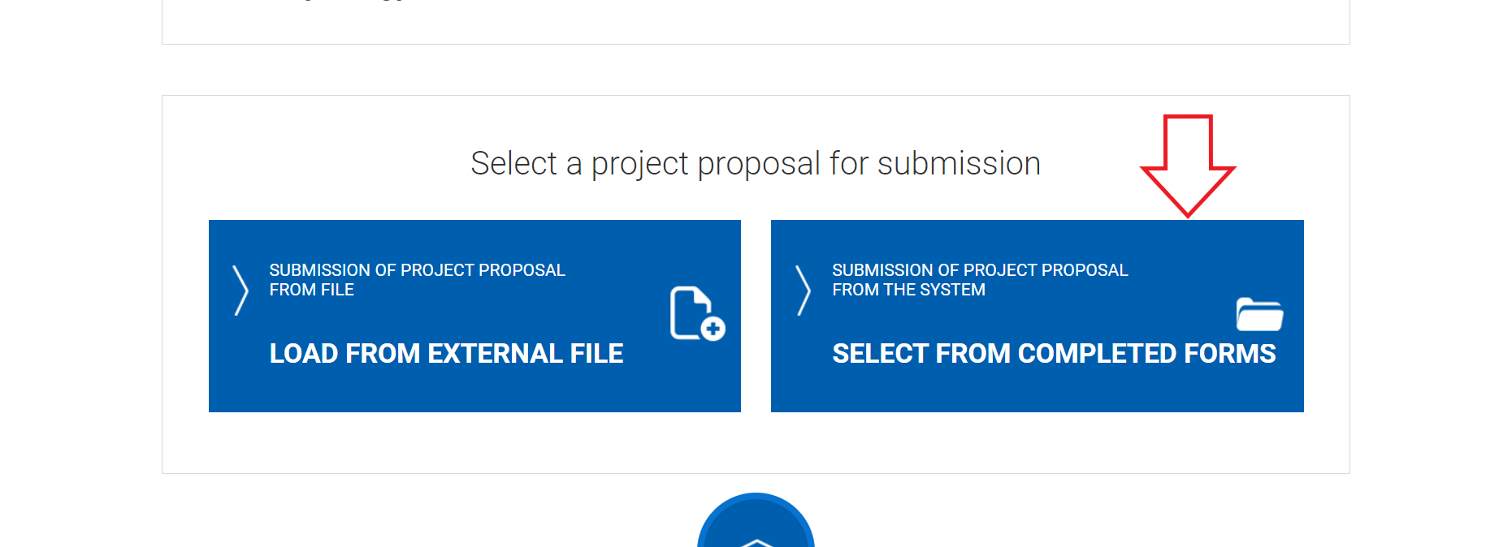

You will be taken to a screen, on which you will be able to see your proposal and must slick on “SUBMIT PROPOSAL”:

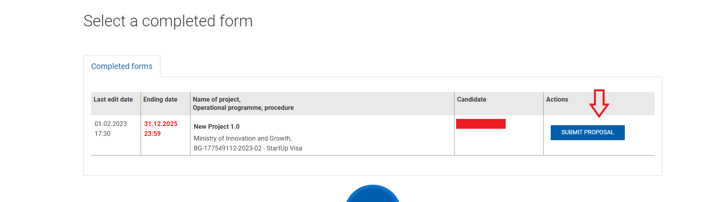

After clicking on “SUBMIT PROPOSAL” you will be able to see and make final adjustments to your form and click on “CONTINUE” after you are done:
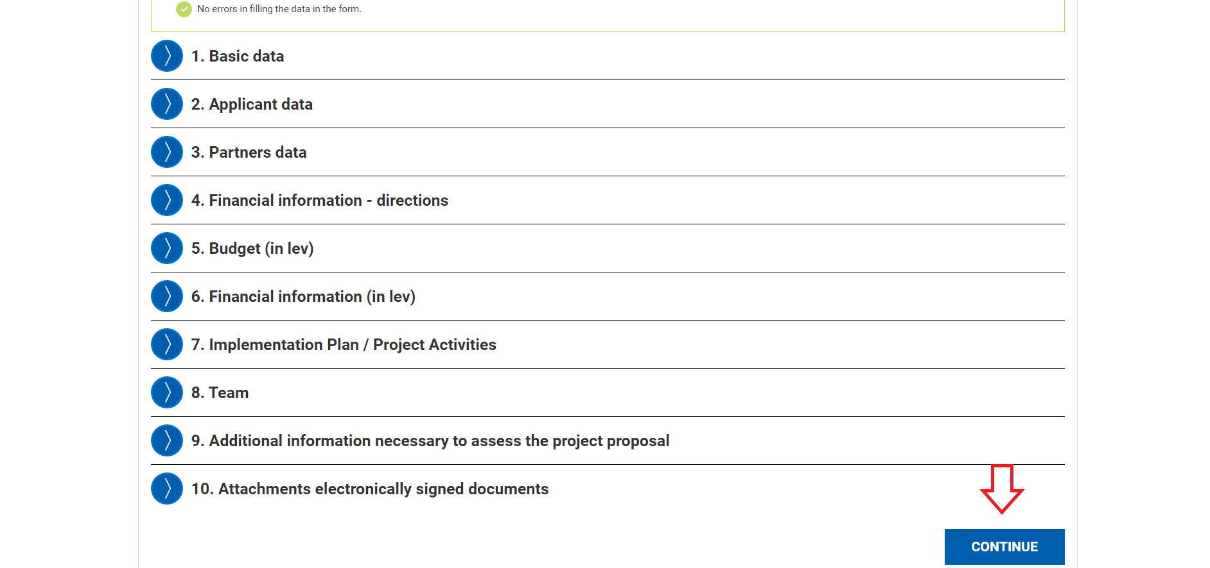

After doing that you will be taken to a page with instructions on how to download, sign and upload the detached signature. Upon completion you have to click on “SUBMISION OF PROJECT PROPOSAL”:
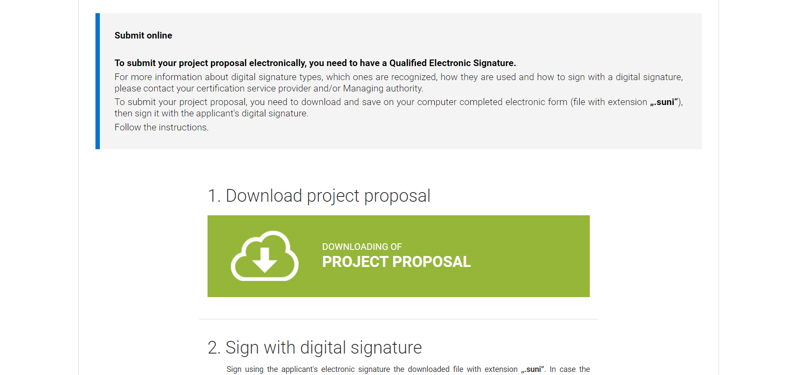
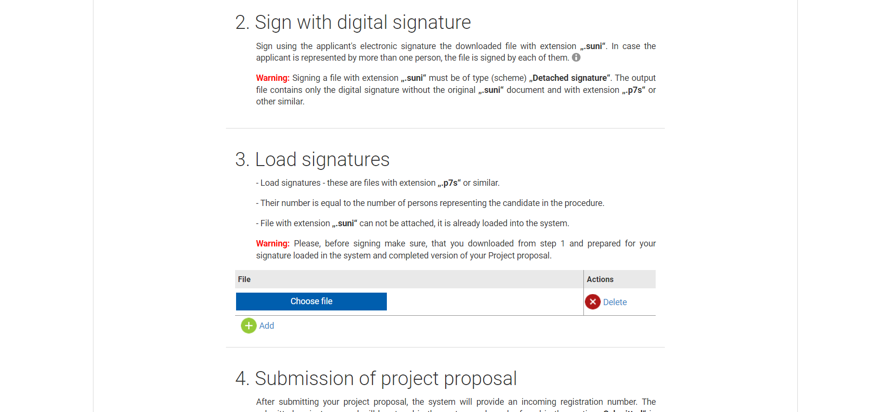

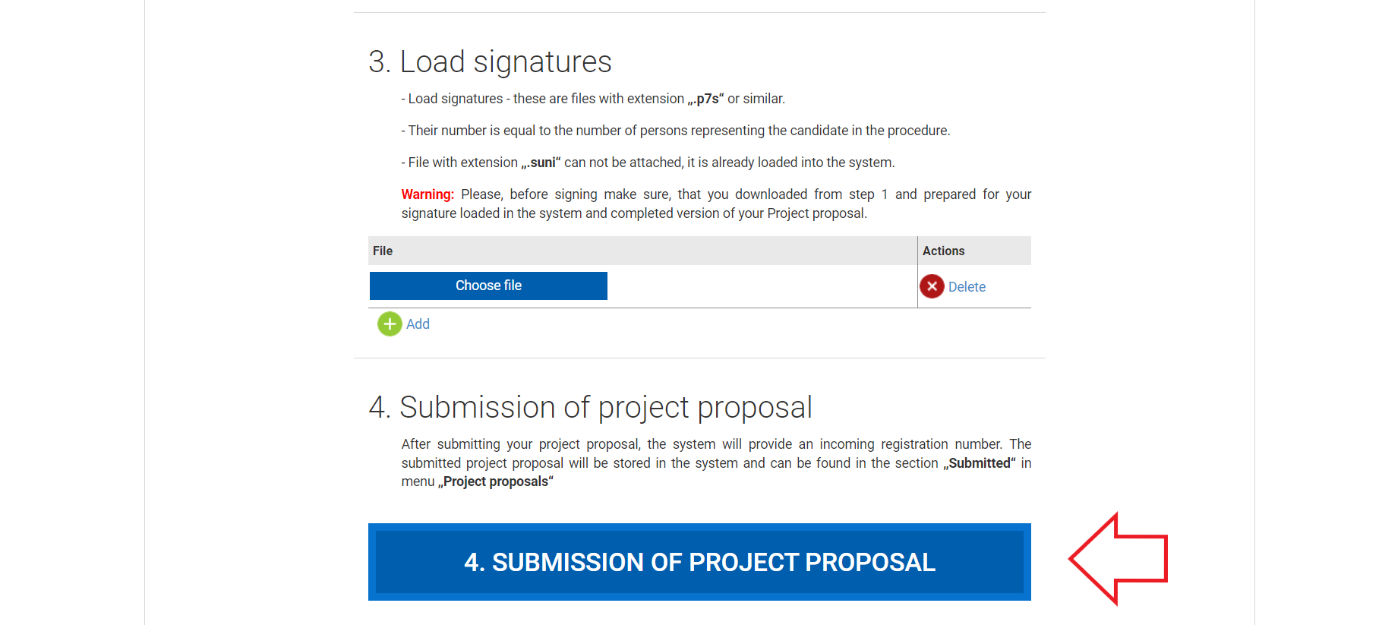

Select the "Download project proposal".
Save the downloaded file on your computer, in a location where there are no other files with the .suni extension.
Using the file signing software specified by the e-signature issuer, sign the downloaded file with the .suni extension. The file should be signed with a so-called Detached signature and the extension of the generated file should be .p7s.
A software-generated signature file with a .p7s extension is typically between 3 KB and 9 KB in size.
Go back to the system and in item 3 "Load signatures" click on "Select file".
Specify the file generated by the signature software with the .p7s extension and load it into the system.
When working correctly, the system will display information about the attached electronic signature and you can proceed to the submission of your project by selecting the "Submit Project Proposal" button.
If when loading the signature file the system displays the message again "Invalid signature or the signature(s) (files with extension ".p7s") do not apply to the project proposal loaded in the system and completed. Please follow the steps above again after deleting the uploaded file", restart the computer and repeat the steps of this instruction, following the strict steps described.
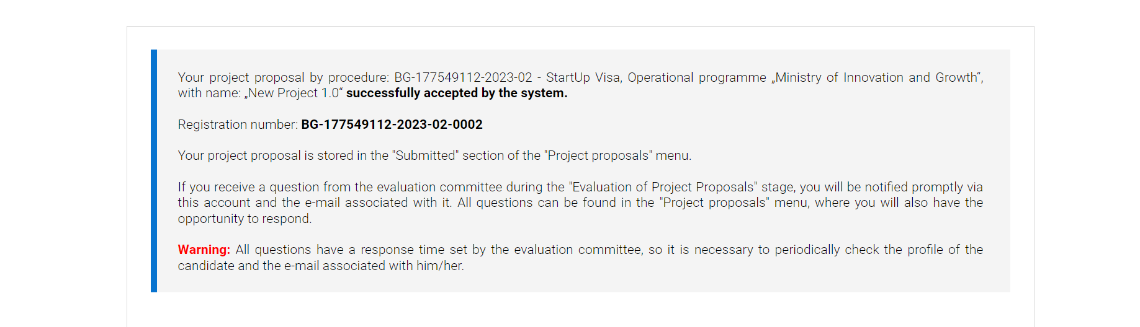
CONGRATULATIONS! You have successfully submitted your project proposal!
Please check your email, on which you would have received a confirmation email of your successfully submitted project proposal.

Should you have any further questions do not hesitate to contact us on : startupvisa@mig.gov.bg
We will respond to you at the earliest convenience.

